**Student Task:**

Use Terraform to create EC2 instance and deploy Apache.

**Instructions:**

1. Create AWS free tier account

2. Create AMI User and use the credentials to connect Terraform with the AWS provider

3. Create Key Pair in AWS for later use in Terraform

3. Terraform:

A. Create all required resources for the EC2 Instance to get access over the internet (VPC, Subnet, Security Group, etc.)

B. Deploy EC2 Instance with the required resources you configured and install Apache (tip: you can use “user_data” for automatic installation)

C. Use the Key Pair you created on AWS on your instance

C. Output the URL after the terraform apply finished

4. Enter the machine public IP on the browser, if you see Apache Test Page means you successfully configured terraform!

Terraform should output:

Terraform configurations successfully worked:



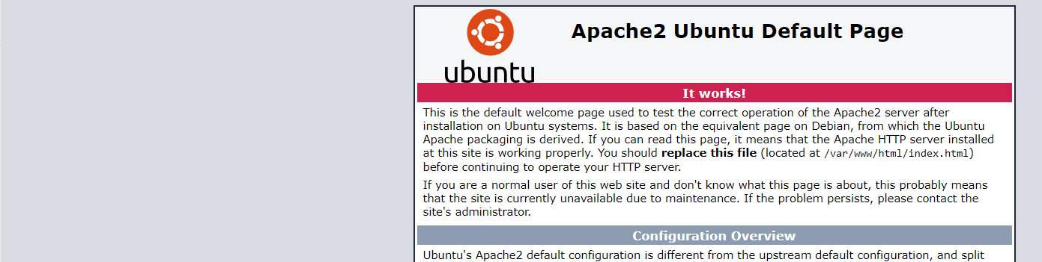

Good Luck!!